Chapter 1: Signals and Amplifiers

1.6 Frequency Response of Amplifiers
- Amplifier bandwidth: the range of frequencies over which the gain of the amplifier is nearly constant
  - Normally, amplifiers are designed so that their bandwidth corresponds to the frequencies of the input signals they need to amplify
$$a+jb=\sqrt{a^{2}+b^{2}}e^{j\tan^{-1}{\frac{b}{a}}}$$
$$H(jω)$$ | $$\left|H\left(jω\right)\right| (V/V)$$ | $$\left|H\left(jω\right)\right| (dB)$$ | $$∠H\left(jω\right)$$
$$1+\frac{jω}{ω_{1}}$$ | $$\sqrt{1^{2}+{\left(\frac{ω}{ω_{1}}\right)}^{2}}$$ | $$20\log{\sqrt{1^{2}+{\left(\frac{ω}{ω_{1}}\right)}^{2}}}$$ | $$\tan^{-1}{\frac{ω}{ω_{1}}}$$
$$\frac{1}{1+\frac{jω}{ω_{2}}}$$ | $$\frac{1}{\sqrt{1^{2}+{\left(\frac{ω}{ω_{2}}\right)}^{2}}}$$ | $$20\log{\frac{1}{\sqrt{1^{2}+{\left(\frac{ω}{ω_{2}}\right)}^{2}}}}$$ | $$-\tan^{-1}{\frac{ω}{ω_{2}}}$$
$$\frac{1+\frac{jω}{ω_{1}}}{1+\frac{jω}{ω_{2}}}$$ | $$\frac{\sqrt{1^{2}+{\left(\frac{ω}{ω_{1}}\right)}^{2}}}{\sqrt{1^{2}+{\left(\frac{ω}{ω_{2}}\right)}^{2}}}$$ | $$20\log{\sqrt{1^{2}+{\left(\frac{ω}{ω_{1}}\right)}^{2}}}+20\log{\frac{1}{\sqrt{1^{2}+{\left(\frac{ω}{ω_{2}}\right)}^{2}}}}$$ | $$\tan^{-1}{\frac{ω}{ω_{1}}}-\tan^{-1}{\frac{ω}{ω_{2}}}$$
Bode form: All terms are in the form $1+\frac{jω}{ω_{b}}$

Appendix E: Single Time Constant (STC) Circuits
- Circuits that can be reduced to one resistance (resistor) and one reactive component (inductor or capacitor)
  - Resistor and inductor: $τ=\frac{L}{R}$
  - Resistor and capacitor: $τ=RC$
- Bandwidth/break/cut-off frequency $ω_{b}=\frac{1}{τ}$

E.1 Evaluating the Time Constant
- Zero the voltage (short circuit)/current source (open circuit)
- Reduce the circuit down to one resistor and one capacitor/inductor
- If multiple resistors, find the equivalent resistance $R_{eq}$ seen by the capacitor/inductor
- If multiple capacitors/inductors, find the equivalent capacitance $C_{eq}$ or inductance $L_{eq}$seen by the resistor
- Capacitors:
  - Series: $C_{eq}=\frac{1}{\frac{1}{C_{1}}+\frac{1}{C_{2}}}=\frac{C_{1}C_{2}}{C_{1}+C_{2}}$
  - Parallel: $C_{eq}=C_{1}+C_{2}$
- Inductors:
  - Series: $L_{eq}=L_{1}+L_{2}$
  - Parallel: $L_{eq}=\frac{1}{\frac{1}{L_{1}}+\frac{1}{L_{2}}}=\frac{L_{1}L_{2}}{L_{1}+L_{2}}$

E.2 Classification of STC Circuits
Test at | Replace | Circuit is Low Pass if | Circuit is High Pass if
$$ω=0$$ | C = open circuit  (since $\frac{1}{jωC}=∞$) | Output is finite | Output is zero
L = short circuit
(since $jωL=0$)
$$ω=∞$$ | C = short circuit  (since $\frac{1}{jωC}=0$) | Output is zero | Output is finite
L = open circuit
(since $jωL=∞$)

Appendix F: s-Domain Analysis: Poles, Zeros, and Bode Plots

F1 Poles and Zeros
For a transfer function in the form $H\left(jω\right)=a_{m}\frac{\left(jω-Z_{1}\right)\left(jω-Z_{2}\right)…\left(jω-Z_{m}\right)}{\left(jω-P_{1}\right)\left(jω-P_{2}\right)…\left(jω-P_{n}\right)}$
- The zeros are the roots of the numerator, $Z_{2},Z_{2},…,Z_{m}$
  - The transfer function has $(n-m)$ zeros at $jω=∞$
- The poles are the roots of the denominator, $P_{2},P_{2},…,P_{m}$
  - Complex poles/zeros always occur in conjugate pairs, i.e. if 5+3j is a zero, 5-3j is also a zero
  - Purely imaginary poles/zeros $±jω_{1}$ results in a pole/zero at ${ω=ω}_{1}$
Example: $H\left(jω\right)=a_{m}\frac{10jω}{\left(1+\frac{jω}{{10}^{2}}\right)\left(1+\frac{jω}{{10}^{5}}\right)}$ has one zero at $jω=0$ and one zero at $jω=∞$, and poles at $jω=-{10}^{2}$ and $jω=-{10}^{5}$

Chapter 2: Operational Amplifiers

2.1 The Ideal Op Amp
- Doesn’t draw any input current: i_{i}⁺ = i_{i}⁻ = 0
  - Input impedance of ideal op amp is infinite
  - Output impedance of ideal op amp is zero
- Infinite open-loop gain A / infinite bandwidth
  - V_{i}⁺ = V_{i}⁻ (virtual short in between the terminals)

2.2 The Inverting Configuration
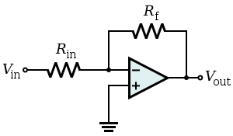
$$v_{1}$$
$$v_{2}$$
- Ideal closed loop gain:
$$v_{0}=A\left(v_{2}-v_{1}\right)$$
$v_{2}-v_{1}=\frac{v_{0}}{A}=0$ (since for an ideal op-amp, $A=∞$)
$\frac{v_{o}}{v_{i}}= -\frac{R_{f}}{R_{in}}$
- Effect of finite open-loop gain:
$v_{1}=\frac{-v_{0}}{A}$ (since v₂ is grounded, v₂ = 0)
$$\frac{v_{0}}{v_{1}}=\frac{-R_{2}∕R_{1}}{1+\left(\frac{1+R_{2}∕R_{1}}{A}\right)}$$

2.3 The Non-Inverting Configuration
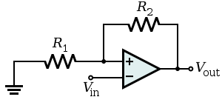
$$v_{in}$$
- Ideal closed loop gain:
$v_{i-diff}=\frac{v_{0}}{A}=0$ (since for an ideal op-amp, $A=∞$)
$$v_{o}=v_{i}+\left(\frac{v_{i}}{R_{1}}\right)R_{2}$$
$$\frac{v_{o}}{v_{i}}= 1+\frac{R_{1}}{R_{2}}$$
- Effect of finite open-loop gain:
$$\frac{v_{o}}{v_{1}}=\frac{1+R_{2}∕R_{1}}{1+\left(\frac{1+R_{2}∕R_{1}}{A}\right)}$$

2.5 Integrators and Differentiators

2.5.2 The Inverting (Miller) Integrator
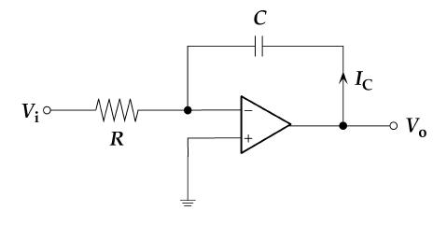
$V_{o}=-v_{c}\left(t\right)$ where $v_{c}\left(t\right)=\frac{1}{C}\int_{0}^{t}{idt}+v_{c}\left(0\right)=\frac{1}{C}\int_{0}^{t}{\frac{v_{i}(t)}{R}dt}+v_{c}\left(0\right)$
$i$
$=-\frac{1}{CR}\int_{0}^{t}{v_{i}\left(t\right)dt}-v_{c}\left(0\right)$
Transfer function:
$\frac{V_{o}(jω)}{V_{i}(jω)}=-\frac{1}{jωCR}$ since $Z_{1}=R$ , $Z_{2}=\frac{1}{jωC}$ , and $\frac{V_{o}(jω)}{V_{i}(jω)}=-\frac{Z_{2}}{Z_{1}}$
$\left|\frac{V_{o}(jω)}{V_{i}(jω)}\right|=\frac{1}{ωCR}$ and phase $=90°$
To limit the DC gain, add a resistor parallel to the capacitor:
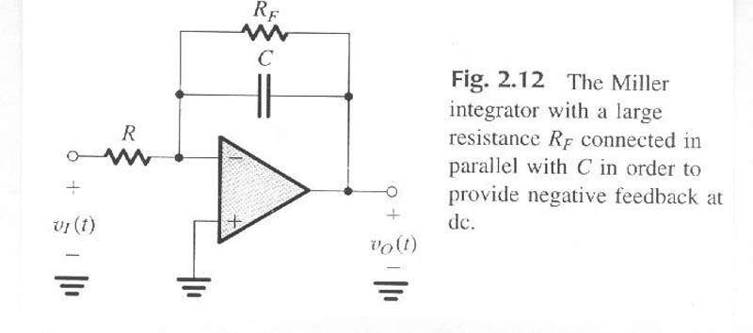
Then $Z_{2}=R_{F} //\frac{1}{jωC}=\frac{R_{F}}{1+jωR_{F}C}$
$$\frac{V_{o}(jω)}{V_{i}(jω)}=-\frac{R_{F}}{R(1+jωR_{F}C)}$$
Low pass filter
- As $ω→0$, $\left|\frac{V_{o}(jω)}{V_{i}(jω)}\right|=-\frac{R_{F}}{R}$
- As $ω→∞$, $\left|\frac{V_{o}(jω)}{V_{i}(jω)}\right|=-\frac{1}{jωRC}$
- $\left|\frac{V_{o}\left(jω\right)}{V_{i}\left(jω\right)}\right|=1$ when $ω=\frac{1}{RC}$

2.5.3 The Op-Amp Differentiator
$$R_{F}$$
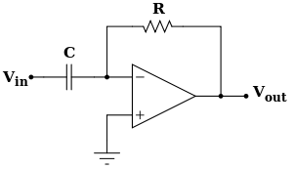
$i$
$V_{o}=-v_{R}$ where $i=C\frac{dv_{i}}{dt}$ and $v_{R}=iR_{F}$
$=-R_{F}C\frac{dv_{i}}{dt}$
Transfer function:
$\frac{V_{o}(jω)}{V_{i}(jω)}=-jωCR_{F}$ since $Z_{1}=\frac{1}{jωC}$ , $Z_{2}=R_{F}$ , and $\frac{V_{o}(jω)}{V_{i}(jω)}=-\frac{Z_{2}}{Z_{1}}$
$\left|\frac{V_{o}(jω)}{V_{i}(jω)}\right|=ωCR_{F}$ and phase $=-90°$
To limit the DC gain, add a resistor $R_{i}$ in series to the capacitor:
Then $Z_{1}=R_{i}+\frac{1}{jωC}$
$$\frac{V_{o}\left(jω\right)}{V_{i}\left(jω\right)}=-\frac{R_{F}}{R_{i}+\frac{1}{jωC}}=-\frac{jωCR_{F}}{1+jωCR_{i}}$$
High pass filter

Band Pass Filter
Combination of integrator and differentiator
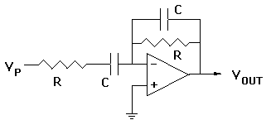
2
1
F
i
$Z_{1}=R_{i}+\frac{1}{jωC_{1}}$ , $Z_{2}=R_{F} //\frac{1}{jωC_{2}}=\frac{R_{F}}{1+jωR_{F}C_{2}}$
$$\frac{V_{o}\left(jω\right)}{V_{i}\left(jω\right)}=-\frac{Z_{2}}{Z_{1}}=-\frac{\frac{R_{F}}{1+jωR_{F}C_{2}}}{R_{i}+\frac{1}{jωC_{1}}}=-\frac{jωC_{1}R_{F}}{\left(1+jωC_{1}R_{i}\right)\left(1+jωC_{2}R_{F}\right)}$$

2.6 DC Imperfections

2.6.1 Offset Voltage
- Ideally, if the two input terminals are connected together and to ground, v_{o} = 0
- However, this isn’t the case; a finite dc voltage exists at v_{o}
- If we connect an input offset voltage V_{os} that is same magnitude, opposite polarity as the finite dc voltage, we can balance out the op amp output v_{o} back to 0

V_{os}
ground
V_{os}
Determining the effect of V_{os} on the op-amp:
- Short-circuit the input voltage and add in V_{os} (superposition – only look at effect of V_{os})
- Non-inverting and inverting configurations become the same circuit
$$V_{o}=V_{os}\left(1+\frac{R_{2}}{R_{1}}\right)$$

2.6.2 Input Bias and Offset Currents
- In order for op amps to operate, they must be supplied with dc currents known as input bias currents I_{B1} and I_{B2}
- The average value of I_{B1} and I_{B2} is the input bias current I_{B}:
$$I_{B}=\frac{I_{B1}+I_{B2}}{2}$$
- The difference between I_{B1} and I_{B2} is the input offset current I_{OS}:
$$I_{OS}=\left|I_{B_{1}}+I_{B2}\right|$$
Determining the dc offset voltage due to the input bias currents:
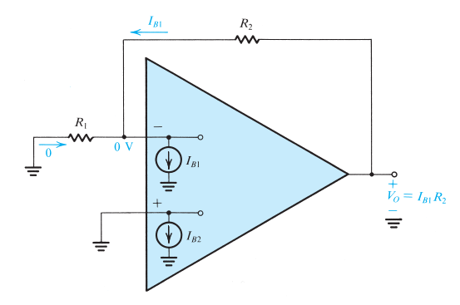
- Ground the input source
- Non-inverting and inverting configurations become the same circuit
$$V_{o}=I_{B1}R_{2}≈I_{B}R_{2}$$
Reducing the effect of I_{B}:
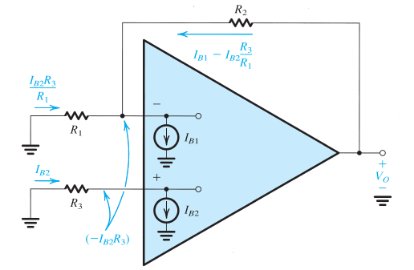
- Introduce resistance R₃ in series with the non-inverting input lead (where I_{B2} is)
$$V_{o}=-I_{B2}R_{3}+{(I_{B1}-I_{B2}\frac{R_{3}}{R_{1}})R}_{2}$$
  - If I_{B} = I_{B1} = I_{B2}:
$$V_{o}=-I_{B}R_{3}+{\left(I_{B}-I_{B}\frac{R_{3}}{R_{1}}\right)R}_{2}$$
$$= I_{B}(R_{2}-R_{3}\left(1+\frac{R_{2}}{R_{1}}\right))$$
  - We can reduce V_{o} to zero by choosing $R_{3}$ such that $R_{3}\left(1+\frac{R_{2}}{R_{1}}\right)= R_{2}$, so that V_{o} = 0:
$$R_{3}=\frac{R_{2}}{1+R_{2}/R_{1}}=\frac{R_{1}R_{2}}{R_{1}+R_{2}}=R_{1} // R_{2}$$

2.7 Effect of Finite Open-Loop Gain and Bandwidth on Circuit Performance

2.7.1 Frequency Dependence of Open-Loop Gain
- The open loop gain A of an op amp is finite – it decreases with frequency
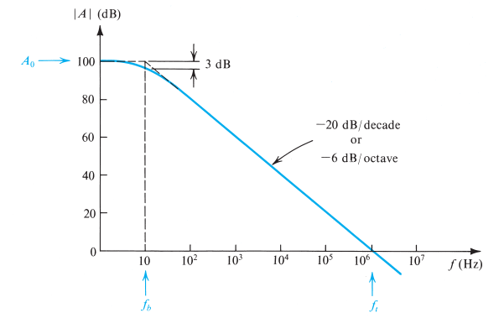
- $A\left(jω\right)=\frac{A_{0}}{1+jω/ω_{b}}$
  - $A_{0}$ – dc gain
  - $ω_{b}=2πf_{b}$ – “corner/break”/3-dB frequency (frequency where gain begins to decrease)
- When $ω≫ω_{b}$:
$A\left(jω\right)≅\frac{A_{0}ω_{b}}{jω}$ (got rid of the 1 in the denominator) which means $\left|A\left(jω\right)\right|=\frac{A_{0}ω_{b}}{ω}$

- The unity gain frequency $ω_{t}$is the frequency when the gain reaches unity (0 dB)
  - From $\left|A\left(jω\right)\right|=\frac{A_{0}ω_{b}}{ω}$, $0dB=1\frac{V}{V}$ and so $ω_{t}=A_{0}ω_{b}$
  - Substituting: $A\left(jω\right)≅\frac{ω_{t}}{jω}$
- The unity gain bandwidth $f_{t}=ω_{t}/2π$is the bandwidth where the gain reaches 0 dB
  - The gain magnitude can also be expressed as: $\left|A\left(jω\right)\right|=\frac{ω_{t}}{ω}=\frac{f_{t}}{f}$

2.7.2 Frequency Response of Closed-Loop Amplifiers
Inverting configuration:
$$\frac{v_{0}}{v_{i}}\left(jω\right)=\frac{-{R_{2}}/{R_{1}}}{1+{\dot{j}ω}/{\frac{ω_{t}}{1+{R_{2}}/{R_{1}}}}}$$
Non-Inverting configuration:
$$\frac{v_{0}}{v_{i}}\left(jω\right)=\frac{1+R_{2}∕R_{1}}{1+\dot{j}ω∕\frac{ω_{t}}{1+R_{2}∕R_{1}}}$$
$$ω_{b}=\frac{ω_{t}}{1+R_{2}∕R_{1}}$$

2.8 Large-Signal Operation of Op Amps

2.8.1 Output Voltage Saturation
- Op amps operate linearly over a limited range of output voltages
- Op amp output saturates such that L⁺ and L⁻ (upper and lower limits) are within ~1V of the positive and negative power supplies
  - E.g. an op amp with +/- 15V power supplies will saturate when the output voltage reaches around +13V in the positive direction and -13V in the negative direction, so the rated output voltage is said to be +/- 13V

2.8.2 Output Current Limits
- The output current of op amps is limited to a specified maximum; under no circumstances should the op amp be required to supply an output current over the maximum (in either direction)
- If the circuit requires a larger current, the op-amp output voltage will saturate at level corresponding to the maximum output current

ECA Chapter 8: Basic RL and RC Circuits
Resistors
$$V_{R}=iR$$
Power dissipated by a resistor: $P_{R}=i^{2}R=\frac{V^{2}}{R}$
Inductors
$$V_{L}=L\frac{di_{L}(t)}{dt}$$
- If current is constant, V = 0
- Current can’t change instantaneously (must be continuous)
Energy stored in inductor: $W_{L}=\frac{1}{2}Li^{2}$
Capacitors
$$i_{C}\left(t\right)=C\frac{dv_{c}(t)}{dt}$$
- If voltage is constant, i = 0
- Voltage can’t change instantaneously (must be continuous)
Energy stored in capacitor: $W_{C}=\frac{1}{2}CV^{2}$

8.1 The Source-Free RL Circuit – Natural Response
Natural response: a circuit’s response to stored energy
$-v_{L}=v_{R}$ $$-L\frac{di\left(t\right)}{dt}=Ri(t)$$
$$\frac{di\left(t\right)}{i\left(t\right)}=-\frac{R}{L}dt$$
$$\ln{i(t)}|_{I_{0}}^{i(t)}=-\frac{R}{L}t|_{0}^{t}$$
$$\ln{\frac{i\left(t\right)}{I_{0}}}=-\frac{R}{L}t$$
$$i\left(t\right)=I_{0}e^{-\frac{R}{L}t}$$

8.2 Properties of the Exponential Response
Time Constant
𝜏 = the time it takes $i/I_{0}$ to decrease from unity to 0, assuming a constant rate of decay
- For RL circuits, $τ=\frac{L}{R}$
- For RC circuits, $τ=RC$

8.3 The Source-Free RC Circuit – Natural Response
$${ v}_{C}=v_{R}$$
$$v_{c}=-RC\frac{dv_{c}}{dt}$$
$$\frac{dv_{c}}{v_{c}}=-\frac{1}{RC}dt$$
$$\ln{v_{c}}|_{V_{0}}^{v_{c}(t)}=-\frac{1}{RC}t|_{0}^{t}$$
$$\ln{\frac{v_{c}(t)}{V_{0}}}=-\frac{1}{RC}t$$
$$v_{c}\left(t\right)=V_{0}e^{-\frac{1}{RC}t}$$

8.4 A More General Perspective
$$x\left(t\right)=x\left(0^{+}\right)e^{-t/τ}$$
- For inductors, $i_{L}\left(0^{-}\right)=i_{L}(0^{+})$
- For capacitors, $v_{c}\left(0^{-}\right)=v_{c}\left(0^{+}\right)$

8.6–8.8 Step Response of RC/RL Circuits
First order circuit: A circuit that can be reduced to one with a single energy storage element (inductor or capacitor)
Step response: A circuit’s response to a step (abrupt) change in its input
- Find the initial and final values of the variable of interest – $x\left(0^{-}\right), x\left(0^{+}\right), x(∞)$
- The solution is equal to $x\left(t\right)=x\left(∞\right)-\left(x\left(∞\right)-x\left(0^{+}\right)\right)e^{-t/τ}$
- $τ=R_{eq}C$ or $τ=\frac{L}{R_{eq}}$

Chapter 9: The RLC Circuit

9.1 The Natural (Source-Free) Response of Parallel RLC Circuits
Resistor: $i_{R}=\frac{v}{R}$
Inductor: $v=L\frac{di_{L}}{dt} → i_{L}=\frac{1}{L} \int_{0}^{t}{v dt+i_{L}\left(t_{0}\right)}$
Capacitor: $i_{C}=C\frac{dv}{dt}$
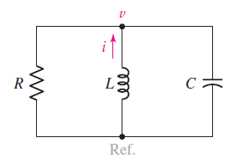
KCL at node:
$$\frac{v}{R}+\frac{1}{L} \int_{0}^{t}{v dt+i_{L}\left(t_{0}\right)}+C\frac{dv}{dt}=0$$
Differentiate to get a 2nd order differential equation:
$$\frac{1}{R}\frac{dv}{dt}+\frac{1}{L}v+0+C\frac{d^{2}v}{dt^{2}}=0$$
$$C\frac{d^{2}v}{dt^{2}}+\frac{1}{R}\frac{dv}{dt}+\frac{1}{L}v=0$$
Assume that the solution is in the form:
$$v\left(t\right)=Ae^{st} → \frac{dv}{dt}=sAe^{st} → \frac{d^{2}v}{dt^{2}}=s^{2}Ae^{st}$$
Substitute into differential equation:
$$Cs^{2}Ae^{st}+\frac{1}{R}sAe^{st}+\frac{1}{L}Ae^{st}=0$$
$$Ae^{st}(Cs^{2}+\frac{s}{R}+\frac{1}{L})=0$$
Solve:
$$Cs^{2}+\frac{s}{R}+\frac{1}{L}=0$$
$$s^{2}+\frac{s}{RC}+\frac{1}{LC}=0 → s_{1},s_{2}=-\frac{1}{2RC}±\sqrt{{\left(\frac{1}{2RC}\right)}^{2}-\frac{1}{LC}}$$
Define:
Neper Frequency: $α=\frac{1}{2RC}$
Resonant Frequency: $ω_{0}=\frac{1}{\sqrt{LC}}$
$$s_{1},s_{2}=-α±\sqrt{α^{2}-ω_{0}^{2}}$$

Case 1: Two real roots ($α^{2}>ω_{0}^{2} → R<\sqrt{\frac{L}{4C}}$) – Overdamped
$$v\left(t\right)=A_{1}e^{s_{1}t}+A_{2}e^{s_{2}t}$$
$$v\left(0^{+}\right)=A_{1}+A_{2}$$
$$i_{C}\left(0^{+}\right)=C\frac{dv}{dt}=C(sA_{1}+sA_{2})$$

Case 2: Repeated real roots ($α^{2}=ω_{0}^{2} → R=\sqrt{\frac{L}{4C}}$) – Critically damped
$$v\left(t\right)=A_{1}e^{st}+A_{2}te^{st}$$
$$v\left(0^{+}\right)=A_{1}$$
$$i_{C}\left(0^{+}\right)=C\frac{dv}{dt}=C(sA_{1}+sA_{2})$$

Case 3: Complex roots ($α^{2}<ω_{0}^{2} → R>\sqrt{\frac{L}{4C}}$) – Underdamped
$$s_{1},s_{2}=-α±j\sqrt{ω_{0}^{2}-α^{2}}$$
Natural Resonant Frequency
$$ω_{d}=\sqrt{ω_{0}^{2}-α^{2}} → s_{1},s_{2}=-α±jω_{d}$$
$$v\left(t\right)=e^{-αt}(B_{1}\cos{ω_{d}t}+B_{2}\sin{ω_{d}t})$$
$$v\left(0^{+}\right)=B_{1}$$
$$i_{C}\left(0^{+}\right)=C\frac{dv}{dt}=Cω_{d}B_{2}$$

Solving a Parallel RLC Circuit
- Determine damping (compare $R$ to $\sqrt{\frac{L}{4C}}$)
- Select correct form of equation
- Use two initial conditions $i_{L}\left(0\right)$ and $v_{C}(0)$ to solve for constants

9.5 The Natural (Source-Free) Series RLC Circuit
Resistor: $v_{R}=iR$
Inductor: $v_{L}=L\frac{di}{dt}$
Capacitor: $i=C\frac{dv_{c}}{dt} → v_{C}=\frac{1}{C}\int_{0}^{t}{i dt}+v_{c}(0)$
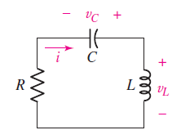
KVL around loop:
$$iR+\frac{1}{C}\int_{0}^{t}{i dt}+v_{c}\left(0\right)+L\frac{di}{dt}=0$$
Differentiate for 2nd order differential equation:
$$R\frac{di}{dt}+\frac{1}{C}i+0+L\frac{d^{2}i}{dt^{2}}=0$$
$$L\frac{d^{2}i}{dt^{2}}+R\frac{di}{dt}+\frac{1}{C}i=0$$
Assume that the solution is in the form:
$$i\left(t\right)=Ae^{st} → \frac{di}{dt}=sAe^{st} → \frac{d^{2}i}{dt^{2}}=s^{2}Ae^{st}$$
Substitute into equation:
$$Ls^{2}Ae^{st}+RsAe^{st}+\frac{1}{C}Ae^{st}=0$$
$$Ae^{st}\left(Ls^{2}+Rs+\frac{1}{C}\right)=0$$
Solve:
$$Ls^{2}+Rs+\frac{1}{C}=0$$
$$s^{2}+\frac{R}{L}s+\frac{1}{LC}=0 → s_{1},s_{2}=-\frac{R}{2L}±\sqrt{{\left(\frac{R}{2L}\right)}^{2}-\frac{1}{LC}}$$
Define:
Neper Frequency: $α=\frac{R}{2L}$
Resonant Frequency: $ω_{0}=\frac{1}{\sqrt{LC}}$

Solving a Series RLC Circuit
- Determine damping (compare $R$ to $\sqrt{\frac{4L}{C}}$)
- Select correct form of equation
- Use two initial conditions $i_{L}\left(0\right)$ and $v_{C}(0)$ to solve for constants

9.6 The Complete Response of the RLC Circuit
Complete response = natural response + forced response
$$x\left(t\right)=natural response+x(∞)$$
Parallel circuits: $i_{R}+i_{C}+i_{L}=0$
Series circuits: $v_{R}+v_{C}+v_{L}=constant$

Solving for the Complete Response
- Determine initial conditions $x\left(0^{-}\right)$ and $x(0^{+})$
- Obtain numerical value for forced response $x(∞)$
- Complete response = appropriate form of the natural response + forced response
- Evaluate the response and its derivative at t=0 and use initial conditions to solve for constants

Chapter 3/4: Diodes

Non-Linear Circuits
Linear Circuits
- If a source changes by a factor k, all currents and voltages also change by k
- Obeys superposition, i.e. $f\left(a+b\right)=f\left(a\right)+f(b)$
- If input is a sine wave, output is at same frequency (amplitude/phase might change)
Non-Linear Circuits
- Recall: ${\cos\left(ωt\right)}^{2}=\frac{1}{2}(1+\cos{(2ωt)})$
- Doesn’t always obey superposition, i.e. $f\left(x\right)=x^{2} → {\left(a+b\right)}^{2}≠a^{2}+b^{2}$
Example: $f\left(x\right)=2x^{2}$
If$x=cos⁡(ωt)$:
$$f\left(x\right)=2{\cos\left(ωt\right)}^{2}=1+\cos{(2ωt)}$$
If$x=2.5+0.1 cos⁡(ωt)$:
$$f\left(x\right)={2\left(2.5+0.1\cos\left(ωt\right)\right)}^{2}$$
$$=2(6.25+0.5\cos\left(ωt\right)+0.01\cos{{\left(ωt\right)}^{2}}) \\ =12.51+\cos\left(ωt\right)+0.01\cos{(2ωt)}$$
- DC bias
- Signal multiplied by gain (10 in the above equation)
- Distortion - ~1% of the signal (very small)

4.1 The Ideal Diode
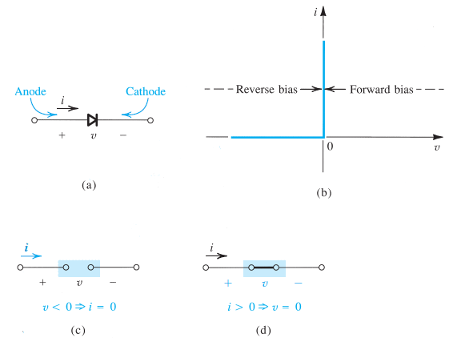
- $I_{D}$ – diffusion current
- $I_{S}$ – drift current
- Reverse bias: $v_{D} ≤0, i_{D}=0$ – diode is off, behaves like open circuit
- Forward bias: $i_{D}≥0, v_{D}=0$ – diode is on, behaves like a short circuit

4.2 Real Diode Behaviour

Forward Bias
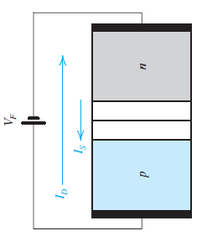
  - Depletion region narrows, so electric potential decreases
  - $I_{D}$ increases – net positive $I_{D}$
  - $I_{S}$ remains constant
Terminal voltage $v_{D}>0$
$$i_{D}=I_{S}(e^{V_{D}/V_{T}}-1)$$
- $I_{S}$ is the saturation current/scale current and is constant for a given diode at a given temperature
- $V_{T}$ is the thermal voltage, ~25 mV at room temperature (20°C)
- We can approximate $i_{D}≈I_{S}e^{V_{D}/V_{T}}$
- Hence, $$v_{D}=V_{T}\ln{\frac{i_{D}}{I_{S}}}$$
Given two sets of $i_{D}/v_{D}$:
$$v_{D1}-v_{D2}=V_{T}\ln{\frac{i_{D1}}{i_{D2}}}$$
A 1mA diode has $v_{D}=0.7 V$ when $i_{D}=1 mA$

Reverse Bias
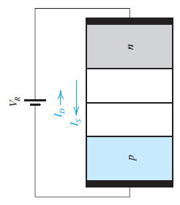
  - Depletion region widens, so electric potential increases
  - $I_{D}$ decreases – net negative $I_{D}$
  - $I_{S}$ remains constant
  - We can approximate $i_{D}≈{-I}_{S}$

4.3 Modeling the Diode Forward Characteristic

4.3.1 The Exponential Model
To find v_{D} and i_{D}:
- Determine if the diode is on or off
- Estimate i_{D} from the circuit
- Use iterations of i_{D} and $v_{D}=V_{T}\ln{\frac{i_{D}}{I_{S}}}$ to find i_{D} and v_{D}

4.3.5 The Constant-Voltage-Drop Model
Diode off: $v_{D}≤0.7V → i_{D}=0$
Diode on: $v_{D}=0.7V → i_{D}≥0$

4.3.6 The Ideal Diode Model
Diode off: $v_{D}≤0V → i_{D}=0$
Diode on: $v_{D}=0V → i_{D}≥0$
Choosing the right model:
- When voltages in the circuit >> v_{D}, simple models are suitable
- If we need v_{D}, must use exponential model

4.3.7 The Small-Signal Model
A diode with a DC voltage and a small AC voitage
$v_{D}(t)=V_{D}+v_{d}(t)$ V_{D} = DC voltage, v_{d}(t) = AC voltage
Then:
$$i_{D}(t)=I_{S}e^{\frac{V_{D}+v_{d}}{V_{T}}}=I_{S} e^{\frac{V_{D}}{V_{T}}} e^{\frac{v_{d}}{V_{T}}}$$
Since $I_{D}=I_{S} e^{\frac{V_{D}}{V_{T}}}$:
$$i_{D}(t)=I_{D} e^{\frac{v_{d}}{V_{T}}}$$
If the amplitude of the AC signal is kept sufficiently small, i.e. $\frac{v_{d}}{V_{T}}≪1$:
$$i_{D}(t)=I_{D} (1+\frac{v_{d}}{V_{T}})$$
$$i_{D}(t)=I_{D}+\frac{I_{D} }{V_{T}}v_{d}$$
Then we can see that $i_{D}(t)=I_{D}+ i_{d}$, where $i_{d}=\frac{I_{D}}{V_{T}}v_{d}$– i_{d} is directly proportional to v_{d}
The Diode’s Small Signal Resistance
From $i_{d}=\frac{I_{D}}{V_{T}}v_{d}$
$$r_{d}=\frac{V_{T}}{I_{D}}$$
A Linearized Model of the Diode
- Set the small signal (AC) to 0 and analyze the DC circuit using a diode model (CVD)
- Replace the diode with its linearized model v_{D}, I_{D}, and r_{d}
- Note: since DC sources get zeroed anyway in the next step, can just replace diode with r_{d}
- We now have a linear circuit, so set all DC sources to zero and find the output due to the small signal v_{d}(t)
- Add the DC value (step 1) to the AC value (step 3) to get the total output

4.6 Diode Rectifiers
Rectifiers allow us to obtain a DC voltage from an AC voltage

4.5.1 The Half-Wave Rectifier
If $v_{S}<V_{D}$, then $v_{o}=0$
If $v_{S}≥V_{D}$, then $v_{o}=v_{S}-V_{D}$
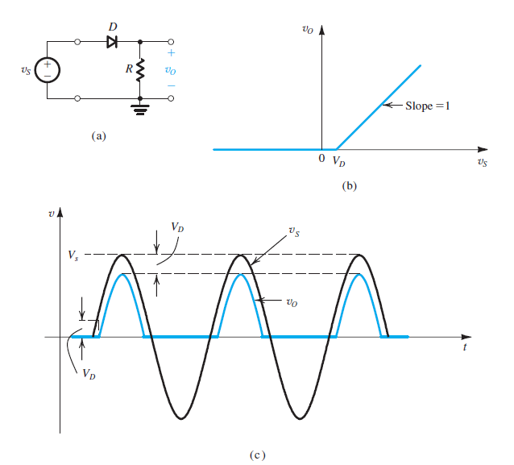
- Peak Inverse Voltage: maximum voltage that diode can withstand before breakdown
- $PIV=V_{s}$ (peak of V_{s})
- $V_{avg}=\frac{V_{p}}{π}$ for ideal diodes ($V_{avg}=\frac{V_{p}}{π}-\frac{0.7}{2}$ for CVD model)
- $V_{rms}=\frac{V_{p}}{2}$

4.5.2 The Full-Wave Rectifier
When $v_{s}≥0$, D1 is on and so D2 must be off
When $v_{s}<0$, D2 is on and so D1 must be off
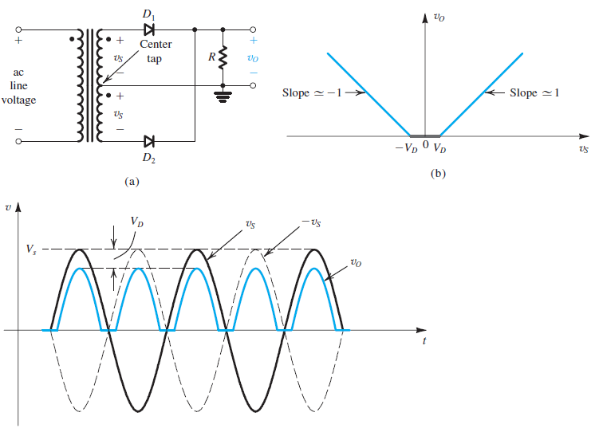
- $PIV={2V}_{s}-V_{D}$
- $V_{avg}=\frac{2V_{p}}{π}$
- $V_{rms}=\frac{V_{p}}{\sqrt{2}}$

4.5.3 The Diode Bridge Rectifier
When $v_{s}≥0$, D1 and D2 are on (forward bias) while D3 and D4 are off (reverse bias)
When $v_{s}<0$, vice versa
- Since there are two diodes at a time in conduction path, $v_{O}=v_{s}-V_{D}$
- $PIV=V_{P}-V_{D}$
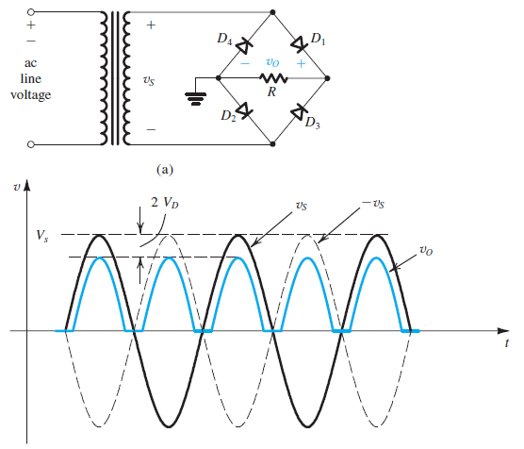

4.5.4 The Rectifier with a Filter Capacitor – The Peak Rectifier
A filter capacitor can be added across the load resistor, to smooth out the output voltage – the circuit outputs the peak of the input sine wave
- Capacitor C charges to the peak of the input ($V_{P}$)
- Diode turns off and C discharges through resistor R
- When $v_{I}$ exceeds the capacitor voltage, the diode turns on again and charges the capacitor up to $V_{P}$
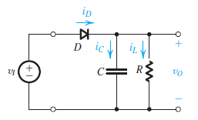
$$i_{L}=\frac{v_{O}}{R}$$
$$i_{D}=i_{C}+i_{L}$$
$$i_{D}=C\frac{dv_{I}}{dt}+\frac{v_{O}}{R}$$
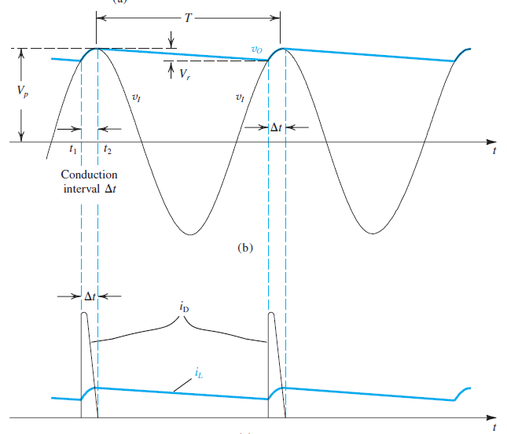
- $∆t$is the time interval where the diode is on
- $T$ is approximately the discharge interval of the capacitor
  - During this time, C discharges through R, so $v_{O}$ decays exponentially with time constant $RC$ – $v_{O}=V_{P}e^{-t/RC}$
- At the end of the discharge interval, $v_{O}=V_{P}-V_{r}$, where $V_{r}$ is the ripple voltage – we assume it is much smaller than $V_{P}$
- When $V_{r}$ is very small, $v_{O}$ is nearly constant the peak input voltage, so the DC output voltage $V_{O}=V_{P}-\frac{1}{2}V_{r}$; then we can say $i_{L}=\frac{V_{P}}{R}$
When the diode is off (during the discharge interval):
$$v_{O}=V_{P}e^{-t/RC}$$
At the end of the discharge interval:
$$V_{p}-V_{r}=V_{P}e^{-T/RC}$$
To keep $V_{r}$ small, we make $CR ≫ T$. Then we can approximate $e^{-T/RC}≈1-T/RC$:
$$V_{r}=\frac{V_{P}T}{RC}=\frac{V_{P}}{fRC}=\frac{I_{L}}{fC}$$

To find $∆t$:
$$V_{p}-V_{r}=V_{P}\cos{ωt} t=T-∆t$$
$$1-\frac{V_{r}}{V_{p}}=\cos{(ω(T-∆t))}$$
$$1-\frac{V_{r}}{V_{p}}=\cos{(2π-ω∆t)}=\cos{(ω∆t)}$$
Approximate $\cos{(ω∆t})≈1-\frac{1}{2}{(ω∆t)}^{2}$:
$$ω∆t=\sqrt{\frac{{2V}_{r}}{V_{p}}}$$
To find average diode current during conduction:
Charge that diode supplies to C = charge that C loses during discharge interval
$$i_{Cavg}∆t=I_{L}T$$
$$i_{Cavg}=\frac{I_{L}T}{∆t} ∆t=\frac{1}{ω}\sqrt{\frac{{2V}_{r}}{V_{p}}}$$
$$i_{Cavg}=\frac{I_{L}}{∆tf}=I_{L}π\sqrt{\frac{{2V}_{p}}{V_{r}}}$$
$$i_{Davg}=i_{C}+i_{L}=I_{L}(1+π\sqrt{\frac{{2V}_{p}}{V_{r}}})$$
The maximum capacitor charging current:
$$v_{c}=V_{P}\cos{ωt} t=T-∆t$$
$$C\frac{dv_{c}}{dt}|_{max}=-Cω V_{P}\sin{ωt}|_{t=T-∆t}$$
$${i_{c}}_{max}=-Cω V_{P}\sin{(ωT-ω∆t)} ωT=2π$$
$${i_{c}}_{max}=Cω V_{P}\sin{(ω∆t)}$$
$${i_{c}}_{max}=Cω V_{P}\sin{(\sqrt{\frac{{2V}_{r}}{V_{p}}})}$$
$${i_{c}}_{max}=Cω V_{P}\sqrt{\frac{{2V}_{r}}{V_{p}}} V_{r}=\frac{V_{p}}{fRC}→ C=\frac{V_{p}}{fRV_{r}}=\frac{I_{L}}{fV_{r}}$$
$${i_{c}}_{max}=I_{L}2π\sqrt{\frac{{2V}_{P}}{V_{r}}}$$
$$i_{Dmax}=i_{C}+i_{L}=I_{L}(1+2π\sqrt{\frac{{2V}_{p}}{V_{r}}})$$

Summary
$$∆t=\frac{1}{ω}\sqrt{\frac{{2V}_{r}}{V_{p}}}=\frac{1}{2πf}\sqrt{\frac{{2V}_{r}}{V_{p}}}$$

Half-wave rectifier with a capacitor
$$V_{r}=\frac{V_{p}}{fRC}$$
$$i_{Davg}=I_{L}(1+π\sqrt{\frac{{2V}_{p}}{V_{r}}})$$
$$i_{Dmax}=I_{L}(1+2π\sqrt{\frac{{2V}_{p}}{V_{r}}})$$

Full-wave rectifier with a capacitor
Ripple voltage is cut in half:
$$V_{r}=\frac{V_{p}}{2fRC}$$
$$i_{Davg}=I_{L}(1+π\sqrt{\frac{V_{p}}{2V_{r}}})$$
$$i_{Dmax}=I_{L}(1+2π\sqrt{\frac{V_{p}}{2V_{r}}})$$

